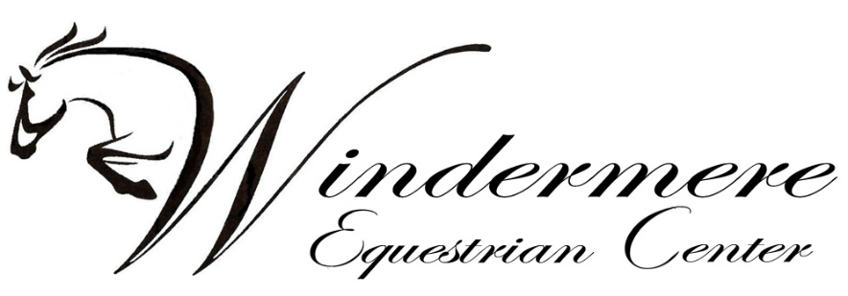

* Make checks payable to: Windermere Equestrian Center
* Mail to or drop off at:   
  Windermere Equestrian Center  
  20615 Dunham Road  
  Clinton Twp., MI 48038
* Tickets will be available for pickup at Windermere Equestrian Center during the April 5th & 6th Winter Series Show, or on banquet night at check-in

Name of Person Ordering Tickets: _________________________________________

Phone Number:______________________ Email:____________________________

Number of Tickets: _______________ ($40/person) *No refunds on seats once form is received*

Amount of Enclosed Check: ________________

Name of Trainer/Barn you wish to be seated with: ____________________________

Banquet doors open at 5:00 PM  
Dinner to be served at 6:00 PM

Join us for dinner, awards, music and dancing hosted by local radio host Holly Hutton

**Date & Location:**

Friday, April 11, 2025

Penna’s of Sterling  
38400 Van Dyke Ave  
Sterling Heights, MI 48312

You’re Invited!

Join us for the 2024 – 2025 Winter Series Awards Banquet